Online Bulletin Board User Guide

(Super Administrator)

This guide is for the super administrator which controls important parts of the website. The super administrator is not a user of the website, it is only used to change some parts of the system.

Roles of the Super Administrator:

1. View all files and delete folders
2. View all archived files
3. View all employees
   1. Edit details such as username and team
   2. Activate / Deactivate an account
   3. Delete user account
4. Add employees into the system
5. Grant/Revoke admin accounts to users.
6. View team members
7. Manage teams
   1. Add a team
   2. Edit team name
   3. Delete team
8. Manage file types for uploading
   1. Add file types accepted
   2. Edit file types accepted
   3. Delete file types accepted
9. **Login**

To access the system, enter these:

Username: SUPERADMIN

Password: SUPERADMIN123

Then click the Login button.

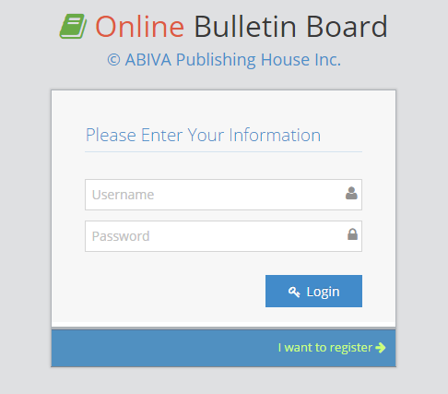

If you have provided the correct username and password, you will be redirected to the index page of the system. Otherwise you will be prompted with this dialog box:

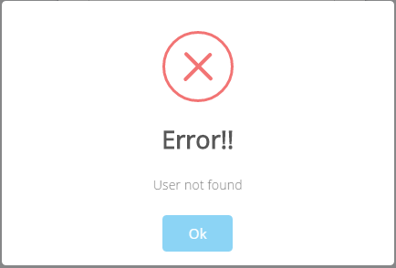

1. **Index Page and Menu**

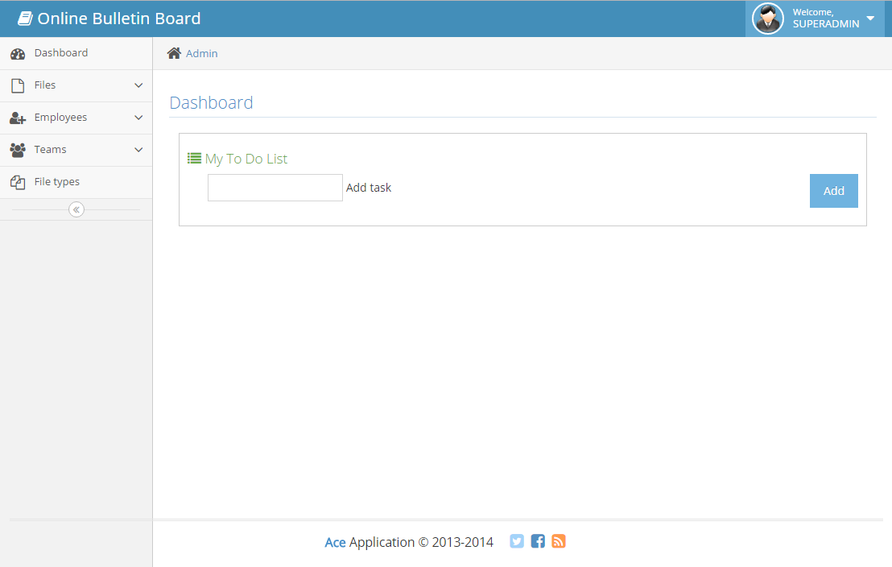

This is the index page in which the user will be redirected to after logging in. You can also see the side menu which will help you in navigating the system.

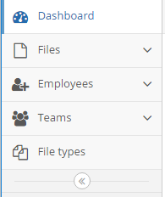

The index page provides a to do list. To use this, input any text in the Add Task field then click the Add button.

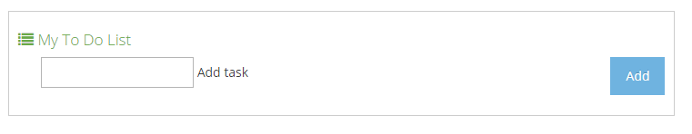

The task you’ve entered will be enumerated in a list.

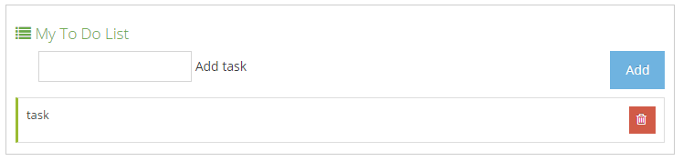

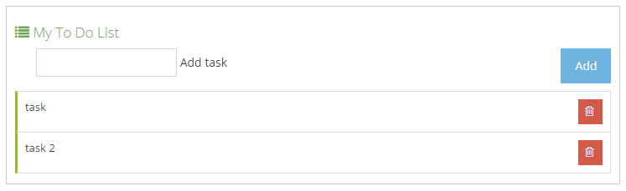

To mark a task as finished, click its row once. Click it again to remove the mark.

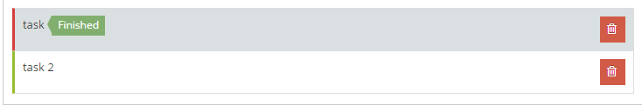

Click the button to delete a task.

1. **Profile (Super admin used for changing password, other details cannot be seen by anyone)**

Click the button

You will be redirected to the User Profile Page. You can see the details you have registered.

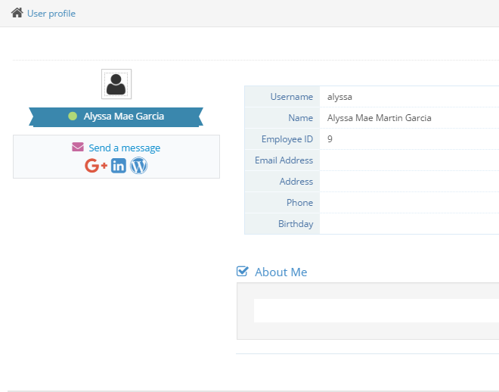

You are able to fill out the blank fields in the form by clicking the button found at the upper right corner of your screen.

After clicking the Edit Profile button, you will are now able to fill out and provide additional details to your profile.

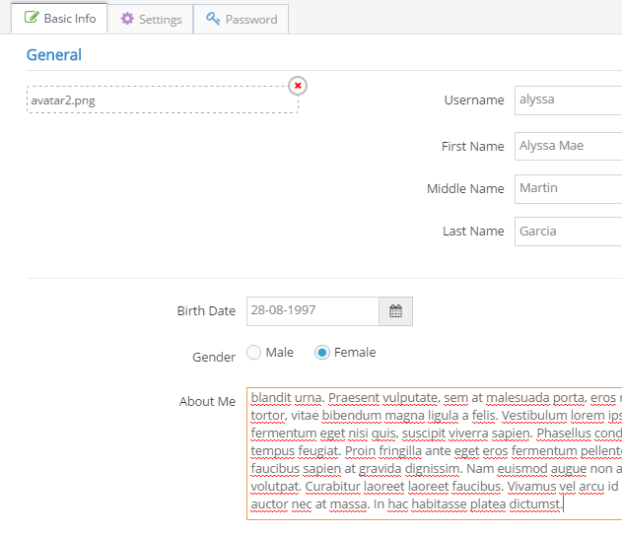

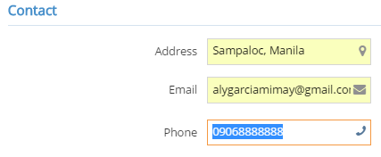

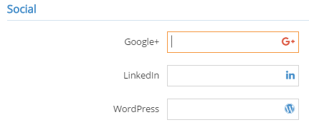

To change your profile picture, click this:

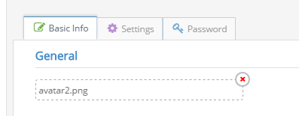

The file chooser will show, then choose your profile picture.

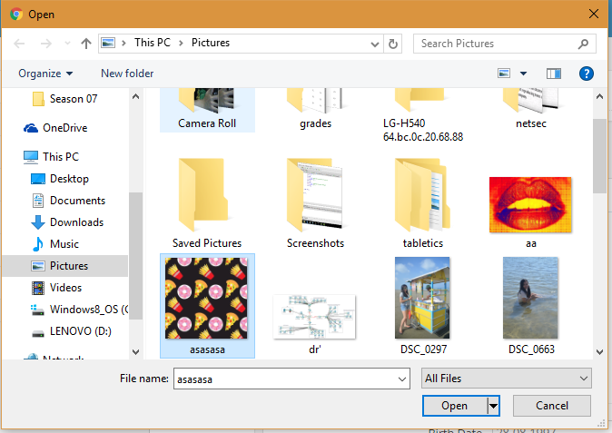

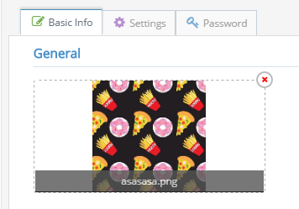

Click the  button at the bottom part of the form to save your information.

After saving, you can now see you updated user profile.

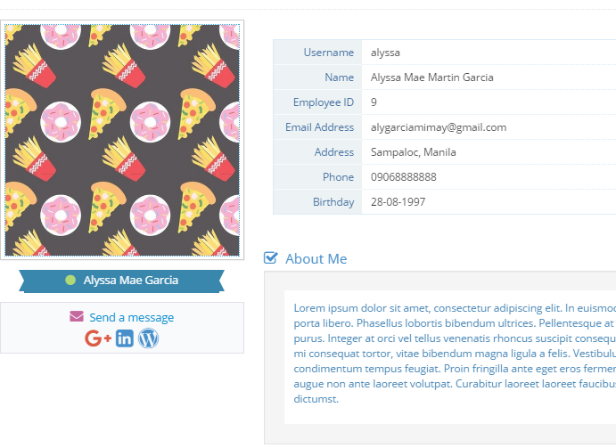

1. **Change Password**

Click  then click the Password tab that can be seen at the top panel of the form.



This will then show this form:

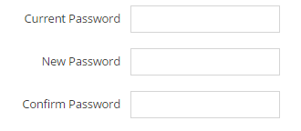

To change password, enter your current password then enter your new password. If you have successfully changed your password, you will see this:

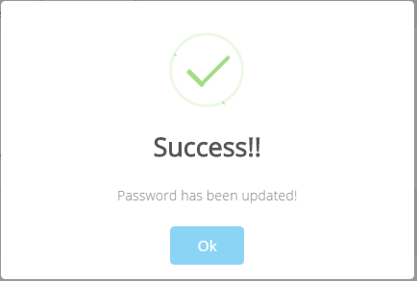

Otherwise, you will be prompted with this:

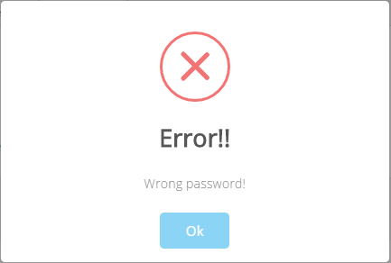

Your old password cannot be the same as your new password.

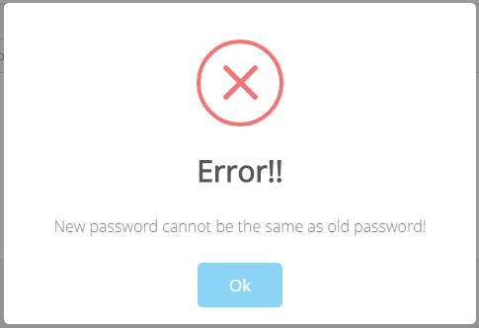

1. **Employee Management**

Click the Employees tab on the side menu. Then click Add Employees.

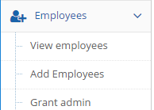

You will be redirected to a form which enables you to register new users.

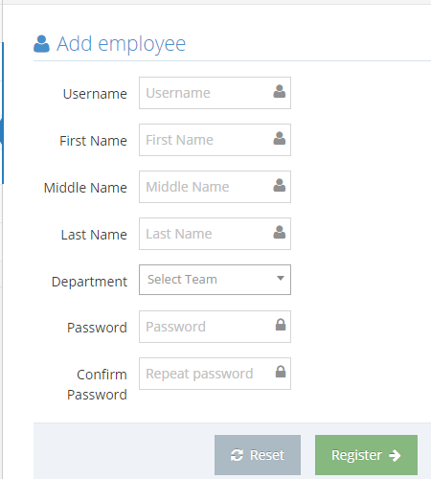

Fill out all of the input fields in the form then click the button found at the bottom of the form. If you have successfully registered a new user, the system will redirect you to  tab.

The  tab shows you all of the information of all employees registered in the system. This tab enables you to edit an employee’s details, and delete an employee. 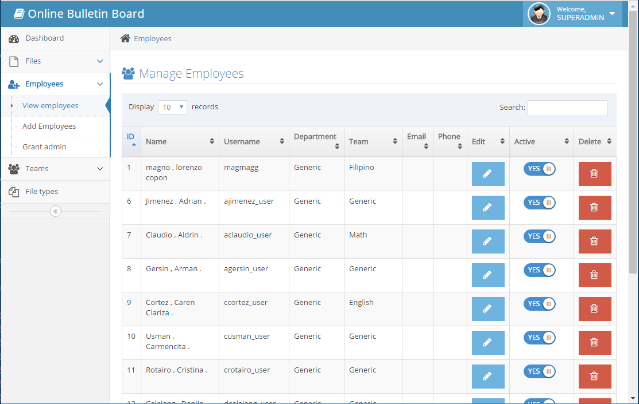

All of the information will be shown in a table. To edit an employee’s info, click the  button found at the Edit column of the table.

Note: When the screen is maximized, the table may not show all of its columns. To view the missing columns, click the ID of the row you want to edit. This applies to all tables available in the system

Clicking the button will trigger the system to show a form.

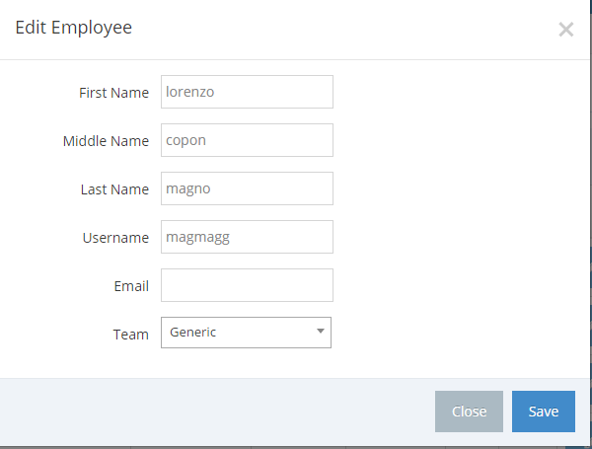

Click the Save button to save your changes.

To delete an employee, click the  button found at the Delete column of the table. A dialog box will then show for confirmation.

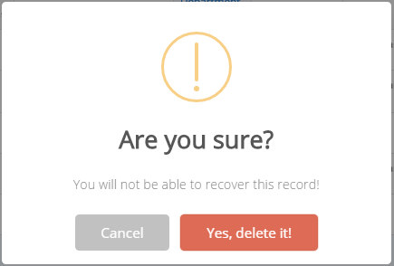

Another dialog box will prompt if you have successfully deleted the employee

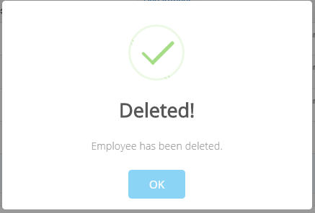

1. **Import Employees**

Click the Add Employees tab

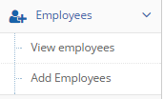

To import employees, look for the dropzone titled Import users beside the Add employee form.

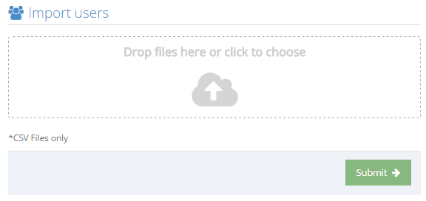

Click the dropzone area and choose a .csv file to import employees. This form only accepts .csv files.

The content/employees listed in the .csv file will be imported to the system after clicking the button.

Go to the View employees tab to see the data you have added.

1. **Grant admin**

Click the “Grant admin” tab

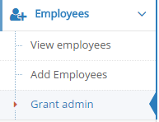

You will then see all the users in the system, simply click on the switch on the right to grant or revoke admin privelages.

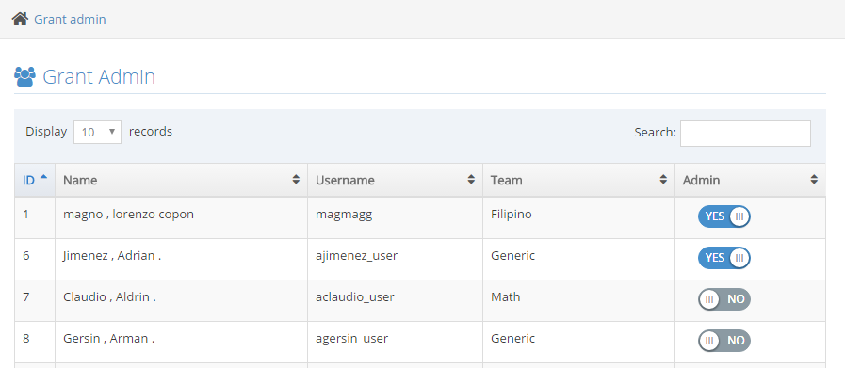

1. **Files**

Click on view files to see all uploaded files in the system.

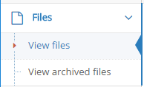

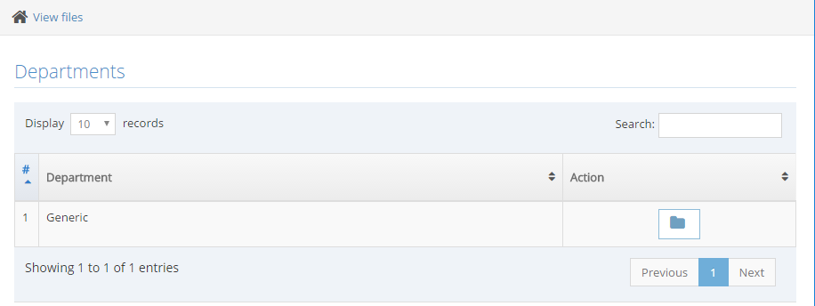

On the top of the page it says “Departments”, this was used in the old system, but now it would only have one folder indicating the department “Generic”. This is due to the introduction of teams and having other “Departments” would be useless.

Click the  button at the Action column of the table. This will enable you to view the folders under the department. Clicking on  deletes the whole folder and files from the system with no backup.

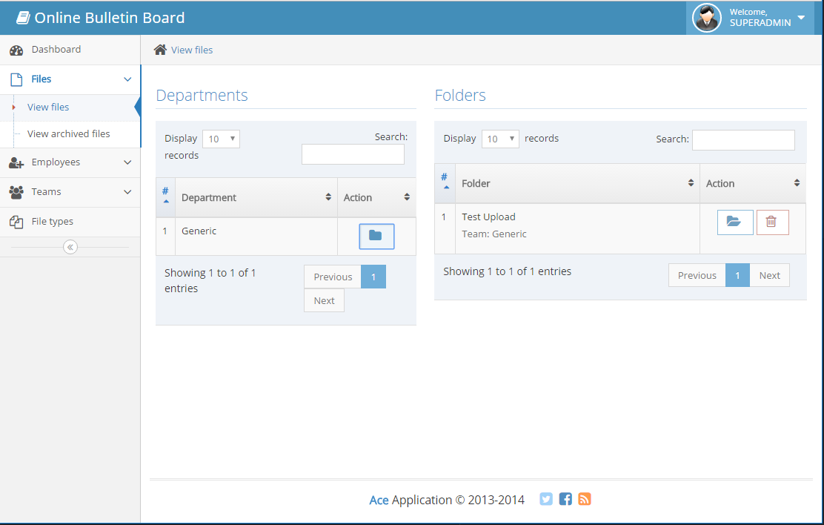

Click the  button found at the Folders table. This enables you to view all of the files uploaded in this folder.

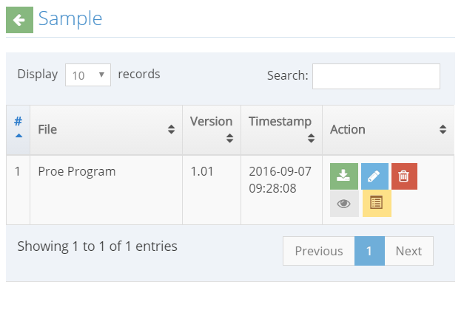

 This button enables you to download the file

 This button deletes the file

 This button lets you view the file. (Not working)

This button triggers a form that enables you to edit the file.

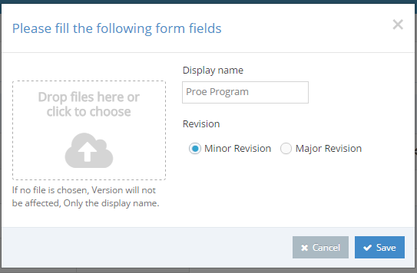

This form lets you upload a new file, input a display name, and choose if the revision made is minor or major.

A minor revision adds a .01 to the current version of your file, while a major revision adds 1 and drops the decimal values.

Ex: File version 1.15 will be file version 2.0 after a major revision.

Click the Save button to save the new version of the file.

You will now see the new version of the file.

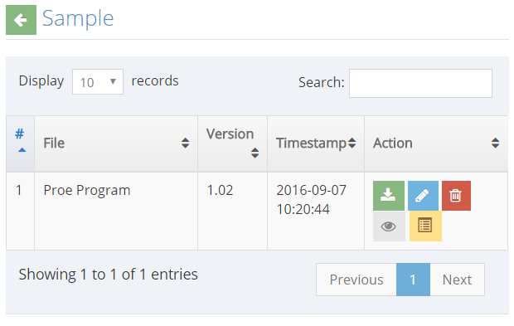

Click the button to view the Archives. This lets you see all of the older versions of the file uploaded in the system.

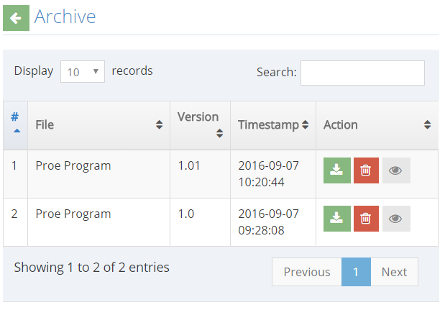

1. **View archived files**

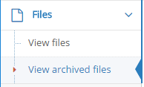

Clicking on “View Archived files” shows all the files that were deleted. This is a “Backup” and here is where you can permanently delete a file from the server. You can still see the archives of deleted files. See the last one who touched the file and see who deleted the file.

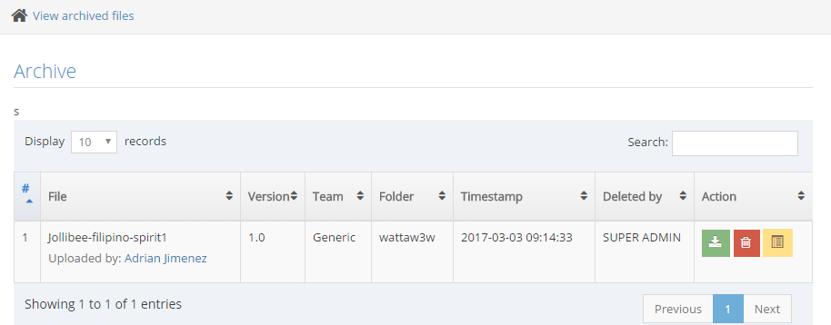

1. **View team members**

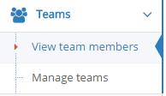

Clicking on “View team members” gives a simple list of the teams and their members

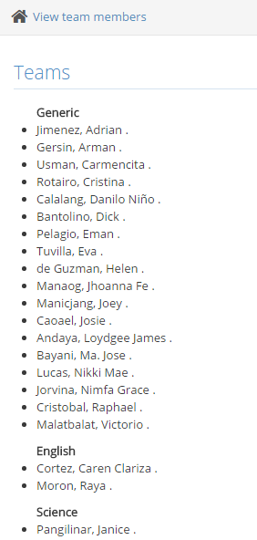

1. **Manage teams**

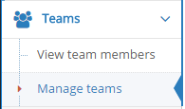

Clicking on “Manage teams” gives a table of all teams wherein the superadmin can Edit the team name, add team name, and delete a team.

NOTE: Deleting a team will move all members to the generic team.

NOTE: Generic team cannot be deleted as this is the default team that everyone is assigned to. But it can be renamed.

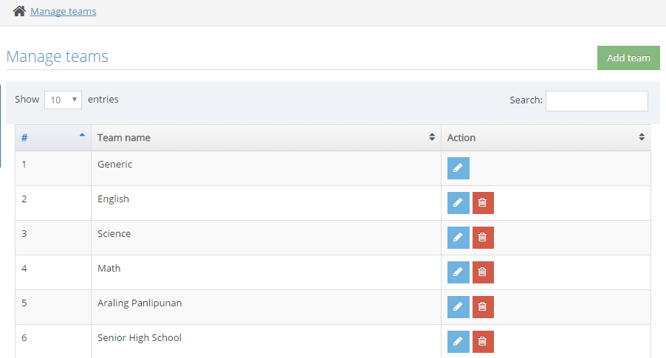

1. **File types**



Clicking on “File types” gives a table of all accepted file types when uploading a file. Here is where you can edit a file extension, delete, and add a file extension.

Note: There is no need to put a .(Dot) in the extension.

Note: All images are by default accepted

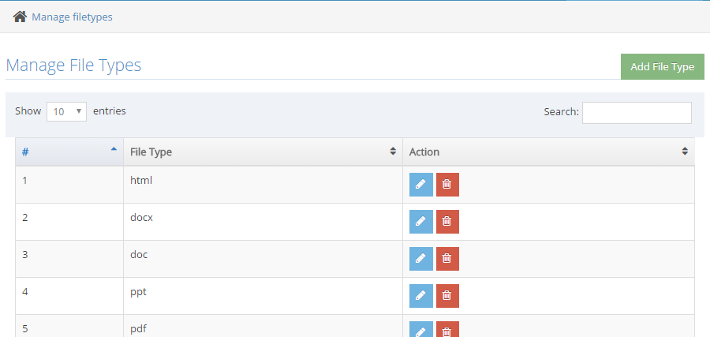

1. **Logout**

To log out, click  that can be found at the upper right corner of your screen. This will show a dropdown menu. Click the logout button and then you will be redirected to the login page.

